APPLICATION BY PARENT/CARER FOR CHILD’S LEAVE OF ABSENCE FROM SCHOOL DURING TERM TIME
Notes to parents/carers
The law does not grant parents an automatic right to take their child out of school during term time. If the request is for an absence in term time you must have Parental Responsibility and be the parent with whom the child normally lives. Permission must be sought in advance and must be for exceptional circumstances. Schools are only able to consider requests from the person who has parental responsibility and absence will only be authorised in exceptional circumstances.
When deciding whether to allow term time leave, for any reason, the school will only consider:
- The reason for the leave
- The time and duration of the leave
- Whether or not the leave could have been taken during the statutory school holiday periods
- Your child’s record of attendance
- Learning that will be missed

PLEASE NOTE: if the absence request is unauthorised and the child is still taken out of school, this will be unauthorised and may make you liable for a Penalty Notice being issued. The Local Authority will be notified of the holiday taken and a Penalty Notice could be issued for each child taken out of school; this is a fine of
£60 which increases to £120 if not paid within the first 21 days.

To the Headteacher, I wish to apply for:
Name(s) of child (ren): DoB: Class:
DoB: Class:
DoB: Class:

Home Address:

For being authorised for being absent from: to: (inclusive)

Reason for request for absence during term time:
If this is a holiday, please explain the exceptional circumstances which mean that the holiday cannot be taken during a school holiday:
Please note: If you are visiting a country known to practise FGM, we will ask you to confirm that you do not intend to take part in this practise

Signature of Parent/Carer: Name: Date:

Signature of Parent/Carer: Name: Date:

Please ensure you are giving at least 10-days’ notice of the proposed absence, and return this form to the school office.
………………………………………………………………………………………………………………………………………
- Your request has been authorised for the following dates: / / to / /

- Your request has not been authorised for the following reason(s);

Learning that will be missed |  | No exceptional circumstance / exceptional circumstance not accepted |  | Other:
The time and duration of the leave |  | Leave could have been taken during the school holiday periods

Signed: Position: Date:

HOLIDAYS IN TERM TIME
Important: please read the information below carefully:
Warning: If you take your child on holiday in term time without the prior approval of the school, you may be issued a
£60/£120 Penalty Fine, per parent, per child. As a Parent/Carer, you can demonstrate your commitment to your child’s education by, whenever possible, taking your holidays during school holidays
THE FACTS

We recognise that it is often expensive to take a holiday during school breaks and that is why some parents may ask for term time leave for their children. However, it is important that parents carefully consider the implications of taking their child out of school during term time.
Research suggests that children who are taken out of school may never catch up on the work they have missed. This may affect test results and can be particularly harmful if the child is studying for their final year examinations. Children who struggle with English and Mathematics may also find it even harder to cope when they return to school, while younger children may find it difficult to renew friendships with their classmates.

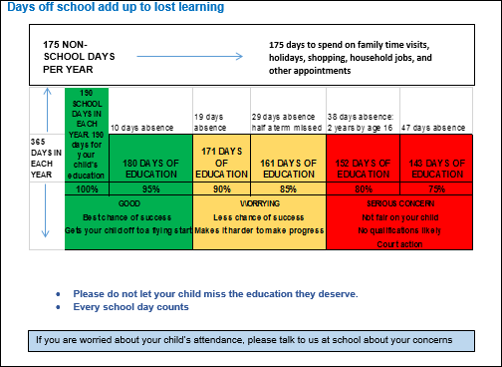
The law does not say that parents have an automatic right to take their child out of school for holidays during term time. In exceptional circumstances, school may authorise, in advance, requests for periods of leave. The request for leave must come from a parent with whom the child normally resides. If a child then stays away from school for more than the authorised period this must be recorded as unauthorised absence and could be quoted in a prosecution for poor attendance.

The Law
The Education (Pupil Registration) (England) (Amendment) Regulations 2013 came into force on the 1st of September 2013. The amendments make it clear that Head Teachers may not grant any leave of absence during term time unless there are exceptional circumstances. Head Teachers should determine the number of school days a child can be away from school if the leave is granted. Holiday prices, and the fact that the parents have booked a holiday before checking with the school, are not exceptional circumstances.

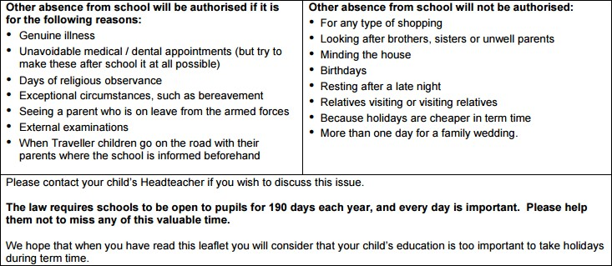
FGM - Our school has a responsibility to ensure that individuals, families and communities know that under the Female Genital Mutilation Act 2003 it is an offence to subject a girl or woman to FGM in the UK; to assist a girl to perform it on herself; for UK nationals or permanent residents to perform FGM abroad; or to assist anyone to perform FGM abroad Please note: We have a statutory duty to report cases of FGM, both known and suspected, to the police and other local authority services.

